Classical strategy overview

Introduction
- Prerequisite to strategy is knowing where you are and where you want to be
- For the assessment, think about counterintuitive questions e.g., why has the industry or company not done as expected?

Understanding strategy
A strategy is a set of objectives, policies and plans that, taken together, define the scope of the enterprise and its approach to survival and success. It is different from vision or tactics.

Factors affecting profitability

Industry effects
- The industry you compete in affects profitability
  - For example, pharma is the most profitable due to patents creating temporal monopolies, and the price elasticity of many products
- Porter’s 5 forces: intensity of rivalry (competitiveness) is a function of the power of buyers, power of suppliers, barriers to entry, threat of substitutes (degree of product differentiation), intensity of rivalry (market concentration ratio) and price and availability of complements.
  - Rivalry is measured by the concentration ratio
  - Threat of substitutes refers to products in other industries, and this threat is high when a product’s demand is positively correlated to a price change in the substitute.
  - Power of buyers is affected by the concentration of buyers, switching costs for buyers (degree to which the product is standardised), the potential of backward/forward integration by buyers/producers.
  - Power of suppliers is affected by the concentration of suppliers, the cost of switching supplier, the potential of forward/backward integration by suppliers/purchasers, the cost of switching suppliers (input standardisation)
  - Barriers to entry are affected by government regulations, patents and proprietary knowledge, economies of scale, asset specificity, entry-deterring strategies by incumbents.
- High competition likely when market growth is low
  - Firms can raise switching costs using loyalty schemes and complementary products
  - Want to maximise power over buyers, suppliers and competitors

Firm positioning
- According to this view, company performance is affected by another dynamic that is distinct from industry structure: the company’s position within its industry

Firm competencies
- Particular competencies affect whether a firm is successful
  - Resources and access to resources
  - Capabilities to exploit these resources
- Resources and capabilities merge to form competence, which is applied to create a cost or differentiation advantage, which allows value creation

Generic strategies
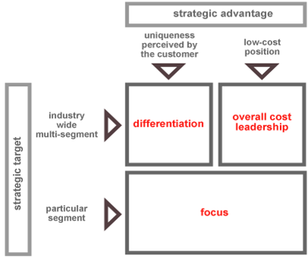
Half of strategy is about adapting to environmental changes, half is about maximising power within the industry. There are three generic types of strategy:
- Differentiation
  - Focused on the whole market
  - Everything is about maximising consumers’ willingness to pay through differentiation
- Cost leadership
  - Focused on the whole market
  - Everything is about delivering cheaper products than competitors or substitute products
  - Or delivering the best value to customers
- Focus
  - Focus on a particular segment of the market

Walmart case study
- Departmental stores sell everything (John Lewis). This requires lots of investment and training for staff to be able to answers consumer questions
  - Discount retailing involves not stocking everything, which therefore does not require staff to have knowledge about the goods being sold e.g., nationally recognised brands or basic necessity goods. This lowers training and labour costs.
- Different product mix to departmental, and broke from the typical discounter strategy of franchising. Stores were wholly only which allowed more control
- Distribution was brought inhouse. Stores would look for catchments of 100,000 people, but Walmart used a regional strategy and could open at the intersection of towns with smaller catchments. This vertical integration created a barrier to entry.
  - Creation of a distribution centre, with stores created within a 100-mile radius of this, in a hub and spoke system. This maximised logistical efficiencies
  - This resulted in strategic growth rather than opportunistic like K-mart, who would find a catchment and open a franchise with a long-term contract
- As they grew, they began to leverage their economies of scale, mainly in the context of bargaining with suppliers
  - Set up reverse auction between suppliers
  - Use products as loss leaders to create dependency.
  - Hard for regulators to know exactly how much to product is costing the firm. Pharma includes marketing costs in R&D costs.
- Investment in IT systems

Strategic fit
- Strategy was cost leadership
- Structure was vertically integrated with its own distribution fleet, cutting out the profit margin of a contracted logistics firm
- Operational efficiency through the hub and spoke system and data management (IT)

Comparing Walmart’s strategy to inferior ones
- How are banks reacting to Fintech? Closing down branches to reduce costs, pitting branches against each other to see who can have the lowest costs
- Walmart invested more in the organisation (IT system, fleet of trucks, opening stores strategically) which allows costs that are lower than anybody else’s in the industry, as opposed to delegating cost-cutting efficiencies to individual stores
  - Delegating cost-cutting responsibilities is is a race to the bottom. Fundamentally unsustainable strategy.

Hinchingbrooke case study
- Within 2 years the firm failed to improve performance and left the contract. They tried to improve performance by cutting costs.
  - Walmart generates its efficiencies centrally and passes them down to the units, it doesn’t tell units to generate efficiencies.
- Configuration of all of the NHS resources it what matters, in a way that generates lower costs. One of the most profitable industries is Pharma and medical equipment manufacturers, bought by the NHS. NHS should exercise monopsony power
  - Hospitals have bought their own supplies rather than NHS buying centrally, which would reduce supplier power.
  - Impose standards on suppliers which prevents differentiation and makes suppliers compete on price. These are our specs, now bid.
  - Standardisation is a powerful tool to bring costs down

Reading

What is strategy, Porter (1996)
- Managers believe positioning is irrelevant as in dynamic markets rivals can quickly copy any market position. This has sometimes led to mutually destructive hyper-competition.
- This is caused by a failure to distinguish between operational effectiveness and strategy. Managers have been unable to translate the gains from outsourcing, TQM, time-based competition etc into sustainable profitability.

Operational effectiveness vs strategy
- Operational effectiveness (OE) is necessary but not sufficient; both this and strategy are essential for superior performance. Preservable competitive advantage is the only way to outperform rivals, i.e., delivering greater value, or comparable value at lower cost.
  - Company differences in price and costs derive from all of the activities required to create, produce, sell and deliver.
  - OE means performing similar activities better than rivals, i.e. more efficiently, reduced defects. Strategic positioning means performing different activities to rivals, or performing similar activities in different ways.
- Differences in OE can stem from waste levels, technology and employee motivation. These were at the heart of the Japanese challenge in the 1980s. Imagine a productivity frontier for an activity, with relative cost position and non-price buyer value on the axes.
  - Increasing OE moves a company toward the frontier, which constantly shifts outward due to new technologies and management techniques. Managers hope to keep up with these shifts using continuous improvement and TQM.
  - Increasingly OE has also exposed false trade-offs between defects and costs.
- Constant improvement in OE is necessary, but not sufficient, to achieve superior profitability. This is due to the rapid diffusion of best practices, particularly for solutions which can be used in multiple settings. Therefore the absolute improvement achieved in OE results in no relative improvement.
  - Another issue is where productivity gains following an increase in OE are capture by consumers and suppliers rather than being retained in superior profitability, e.g. the U.S. commercial printing industry in the 1990s
- Second reason why improved OE is insufficient (competitive convergence) is more subtle. As rivals continually outsource activities to (often the same) efficient third parties, these activities become more generic. These means that strategies converge and competition becomes a series of races down paths that no one wins.
  - Porter cites this as a reason for waves of industry consolidation

Strategy rests on unique activities
- Competitive strategy is about being different, choosing a different set of activities to deliver a unique mix of value. Strategic positioning is often described in terms of customers i.e. tailoring activities to the needs of a customer segment in order to achieve a unique and valuable strategic position.
  - Southwest Airlines offers low-cost short-haul service between midsize cities and secondary airports in large cities. Fast turn arounds allow planes to fly longer hours and provide more frequent departures with fewer aircraft. They do not offer meals, assigned seats or premium class tickets.
  - Ikea targets young, price sensitive buyers seeking style. Ikea customers are happy to trade off service for cost, so there is no sales associate trailing customers around the store, rather are self-service model. Rather than rely on third parties, Ikea designs its own low-cost, ready-to-assemble furniture. If offers in-store childcare and extended opening hours which are services uniquely aligned to the needs of their customers.

Origins of strategic positions
- Based on producing a subset of an industry’s products or services – variety-based positioning. This makes economic sense where a company can best produce particular goods using distinctive sets of activities
- Based on serving most or all of the needs of a particular group of customers i.e., needs-based positioning. Arises when there are groups of customers with different needs, with tailored sets of activities serving these different needs best.
  - Price sensitivity, different product feature requirements, varying amount of information and support requirements.
- Segmenting customers who are accessible in different ways. Known as access-based positioning, where access can be a function of customer geography or scale, or anything requiring a different set of activities to best reach customers.
  - Rural vs urban-based consumers
- Strategy is the creation of a unique and valuable position involving a different set of activities. If there were one ideal position, there would be no need for strategy.

Sustainable strategic position requires trade-offs
- Choosing a valuable position will attract imitation by incumbents, who may attempt to copy in two ways; repositioning itself to match the superior performer or the more common “straddling”. Straddling is matching the benefits of the superior performer whilst maintaining its own position.
- Trade-offs occur when activities are incompatible i.e., more of one necessitates less of another (unless bearing major inefficiencies). Trade-offs create the need for choice and protect against repositioning and straddling incumbents. Trade-offs arise for three reasons:
- Inconsistencies in image or reputation
- From activities themselves i.e., inflexibilities in machinery, people, or systems.
  - Value is destroyed if an activity is overdesigned or under designed for its use.
  - Limiting activity variation often increases productivity
- Internal limits on co-ordination and control. Companies trying to be all things to all customers risk confusion in the trenches as employees have to make decisions without a clear framework.
- Positioning trade-offs create the need for choice and purposefully limit what a company offers and deter straddling and repositioning because this undermines the competitors’ strategies and degrades the value of their activities.
  - N.B false trade-offs between cost and quality exist where there is redundant effort, poor control and accuracy, or weak co-ordination.

Fit drives both competitive advantage and sustainability
- Positioning choices determine which activities a company will perform (and how), and also how these activities relate to one another. OE is about achieving excellence in individual activities or functions, and strategy is about combining activities.
- For example, Southwest’s competitive advantage comes from the way its activities fit and reinforce each other. This fit locks out imitators by creating a chain that is as strong as its strongest link.
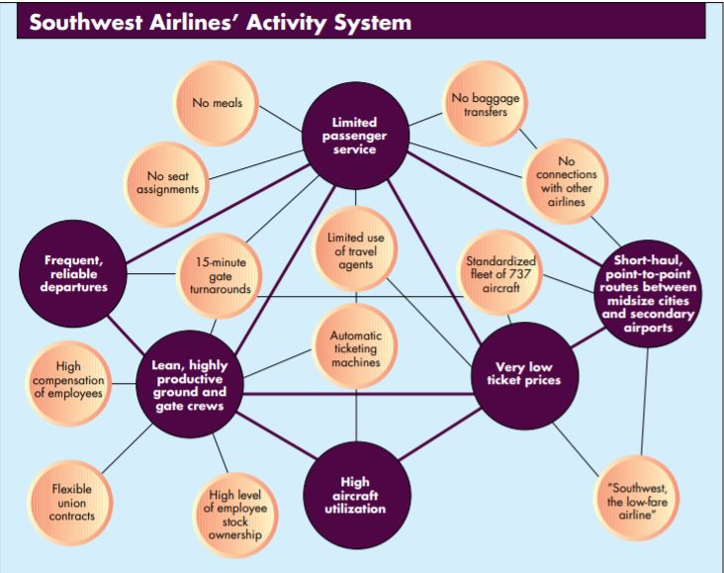
  - One activity’s cost, for example, is lowered because of the way other activities are performed. Same principle applies to value-enhancing activities
- First-order fit is simple consistency between each activity and the overall activity. This ensures the competitive advantages of activities accumulate rather than cancel one another out. Consistency makes the strategy clear to stakeholders and improves implementation due to the single-mindedness in the organisation
- Second-order fit occurs when activities are reinforcing, for example Bic’s combination of point-of-sale activity, heavy television advertising and regular packaging changes yields more impulse buying than any activity in isolation could.
- Third-order fit goes beyond activity reinforcement and achieves an optimisation of effort. Most basic type of effort optimisation is co-ordination and information exchange across activities to eliminate wasted effort. There are higher levels as well:
  - Product design choices can eliminate the need for after-sales service or make it possible for consumers to perform the activity themselves.
  - Co-ordination with suppliers can eliminate the need for in-house activities

Fit and sustainability
- Fit is also fundamental to sustainability of the competitive advantage it creates. It is harder for a rival to match an array of interlocked activities than merely imitate a particular sales-force approach or product features.
  - Many interlocked, reinforcing activities can act as a barrier to imitation as it means that rivals derive little benefit from imitating activities if they do not imitate the whole system. This increases the costs of imitation and the probability of failure.
  - Further, second and third order fit are particularly effective in creating sustainability of the competitive advantage.
- Fit increases pressures and incentives to increase operational effectiveness because poor performance in one activity degrades the performance of others, exposing weakness and magnifying their costs. This increase in OE presents another barrier to potential imitators.

Walmart analysis, Yoffie and Slind (2007)
- Slipping net sales growth, accentuated by its expansion from rural to urban markets, where chief rival Target was historically strong
- Strategy to deal with this was focus on improving merchandising and store formats operations, as well as initiatives related to human capital and public relations. Accompanied by an aggressive move into international markets

Walmart’s priorities

Store formats and merchandising strategies
- In 1988 Walmart introduced the supercentre format of larger stores with added products and services alongside traditional merchandising offerings. By 2007 it ran 2,200 supercentres which often also featured speciality shops including restaurants, vision centres, banks etc
- Key question for Walmart is the extent to which they should further differentiate store formats in order to appeal to customers outside their traditional consumer base.
  - They were testing six different store models aimed at serving the needs of a different demographic group: different ethnicities, affluent customers, empty nesters and rural and urban customers
    - For example, widened aisles with faux-wooden floors for affluency

Human capital and public relations
- Walmart had fell in the most admired US company rankings, partially because of criticism pertaining to labour relations. Critics attacked the company for low pay and its reliance on part-time employees in order to reduce healthcare coverage expenses
  - purported failure to enforce child-labour and worker safety rules in relation to its international suppliers.
- In 2005 Walmart launched an unprecedented PR initiative, hiring a large PR firm to roll out a political style “Candidate Walmart” campaign that highlighted its new low-cost generic drug product and its contributions to Hurricane Katrina relief; sponsored an advocacy group called Working Families for Walmart, to showcase its environmental sensitivity
- Meanwhile Walmart maintained its long-standing emphasis on gaining efficiencies through HRM. In 2007 it implemented a computerised scheduling program enabling managers to calibrate labour usage to store needs.
  - Potential trade-off between unpredictably and wage effects for labour vs positive impact on customer service

Walmart’s international operations
- In 2007 Walmart had 1,900 locations in the Americas, 330 in the United Kingdom and 460 in Asia. International operations accounted for 22% of revenues. Walmart experienced highs and lows in its international expansion efforts
  - In some cases, it neglected to adapt to local markets, forcing its culture on certain regions at too rapid a pace
  - Over time though the company has adapted its overseas store formats to local consumer preferences

- In the Americas it combined acquisitions, partnerships and go-at-it-alone ventures to expand.
  - In Mexico it entered a joint venture with the country’s largest retailer, Cifra
  - In Canada it entered by acquiring 12 Woolco stores
  - In Brazil it acquired a leading supermarket chain, Bompreco, and adapted to local customs, for example introducing neighbourhood markets and Mexican-style grocery store hybrids
- In Europe, Walmart entered the UK by acquiring ASDA and Germany by acquiring two hypermarket chains.
  - By 2007 its UK division managed 268 ASDA supercentres and became the nations second largest retailer
  - In Germany, Walmart faced stiff price competition from German “hard discounters” and resistance to its American style merchandising and workplace practices
    - It left the German market in 2006 at a loss of $1bn

Walmart’s competition
- Target was Walmart’s key competitor amongst discount merchandisers, partly by targeting a clientele that was more urban, style conscious and affluent than Walmart’s consumer base.
- K-Mart was another competitor, which merged with department-store chain Sears and opened Super Centres which carried groceries and general merchandise
- Meanwhile, the warehouse concept exemplified by Costco achieved major success

Walmart’s challenges
- Walmart began to slow its growth rate, down to a 7% annual increase in the US from its historic 8% rate, satisfying investors who were worried about new stores cannibalising the sales of older stores.
  - Need to balance the pursuit of growth and returns
- Major questions facing Walmart executives were now could they (and should they) maintain the company’s high historic growth rates, how should they boost their lagging same-store sales, should they continue to extent Walmart’s global reach, and could they find the right strategic formula to compete against Target and other mass retailers in different markets.

McKinsey article – Bradley, Dawson and Smit
- Overcoming the profit-depleting effects of market forces is the essence of good strategy. So, a focus on the presence of market-beating value creation can create a discussion of strategy that is specific and concrete. Market-beating strategies can be identified using economic profit (subtracting the cost of capital from net operating profit)

Strategy is rife with inequality
- Middle 60% of firms generate $29bn economic profit, with $677bn generated by the top quintile. The bottom quintile destroy, $411bn in economic profit

What causes this?
- Components of economic profit are revenues, margins, asset turns and TCR ratio
- Size matters: biggest creators and destroyers of economic profits are large
- High margins differentiate top class of EP performers
- Much of a company’s economic profit depends on the industry in which it operates – industry effect is around 35% for top and bottom quintiles and 50% for the middle
  - Company effect is strongest for best and worst performing firms
  - Vast majority of firms climbing from middle quintiles to top quintiles compete in industry that had also improved in economic profit ranking. Riding on the coattails of an industry-moving trend is almost essential to escaping the middle class
- On average companies in good industries are 3x more likely to generate a market-beating economic profit. However, a below-average company in a good industry appears no more likely to win than an above-average company in a bad one.

How to achieve economic profit?
- On average, 60% of a company’s economic profit is explained by the company effect i.e., drivers of value beside industry-wide ones.
  - Part of this effect could be attributable to more granular market selection choices e.g. segments and geographies
  - But a significant effect is still attributable to a company’s unique advantage through its assets and special capabilities
- If you’re the elite, use it or lose it. Mobilise your capital based on changing conditions

Mastering the building blocks of strategy (Bradley, 2013)
- Left unchecked market forces continually deplete profits. Powerful strategies can counteract this tendency. Focusing on core building blocks can load the dice in favour of a good strategy
  - Gain agreement on the essential decisions and criteria for making them, before creating a strategy
  - Ensure the company is prepared and willing to act on the strategy when adopted.
  - Thinking of a strategy as a journey rather than a project
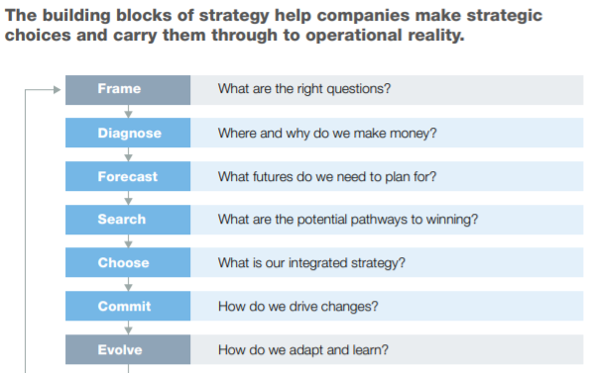
- Framing issues allow you to better identify the real choices and constraints facing your organisation and therefore allows you to see which building blocks are likely to matter most
  - 2/3rds of executives feel rushed to provide outputs in their strategic-planning processes

Have you tested your strategy lately? (Bradley, Hirt, Smit – 2011)
- Ultimately, strategy is a way of thinking, not a procedural exercise or a set of frameworks. To stimulate that thinking, we developed a set of tests to assess the strength of a strategy.
  - Focus on testing the strategy itself (the output of the strategy-development process), rather than the frameworks that generate the strategy

- Will your strategy beat the market? A market imperfection controlled by a company is a competitive advantage; these are scarce as markets drive reversion to mean performance. Good strategies emphasize difference—versus your direct competitors, potential substitutes, and potential entrants.
- Advantages have to be robust and responsive to market forces
- Too many companies “just play along” with the market
- Does your strategy tap a true source of advantage? Competitive advantage stems from two sources of scarcity: positional advantages and special capabilities.
  - Positional advantages are rooted in structurally attractive markets and favour incumbents at the expense of entrants.
  - Special capabilities are scarce resources whose possession confers unique benefits. The most obvious resources e.g., mineral deposits, are “privileged, tradable assets”. A second category is distinctive competencies, which consist of things a company does particularly well e.g., innovating or managing stakeholders
- Is your strategy granular about where to compete? The unit of analysis used in determining strategy, i.e. the degree to which the market is segmented, influences resource allocation thus the likelihood of success
  - Firms should push for the finest possible segmentation of the market e.g., 30-50 instead of five. 80% of the variance in revenue growth is explained by choices about where to compete, leaving only 20% explained by choices on how to compete
  - Defining and understanding segments is one of the most practical things a company can do to improve its strategy
- Does your strategy put you ahead of trends? Many strategies place too much weight on the continuation of the status quo, extrapolating from the past few years, a time frame too brief to capture market forces.
  - Strategist must take trend analysis seriously, focusing on the edges e.g. early adopters and the segment of customers who might be ahead of the curve, or small and innovative entrants.
  - Analyse technologies under development which could change the market
- Does your strategy rest on privileged insights? Most data are cheap and easily accessible to rivals, and therefore is probably insufficient to generate a competitive advantage
  - Create a short list of questions whose answers would have major implications for the company’s strategy
  - Collect new data through observations rather than recycle industry reports
- Does your strategy embrace uncertainty? Try and characterise what level of uncertainty you face (1-4). Companies oscillate between assuming they’re operating at level 1, and succumbing to level 4 paralysis, which is sometimes unnecessary.
  - Understanding the uncertainty level starts with listing variables which would influence a strategic decision, removing impossible outcomes and using economics to highlight which outcomes are mutually reinforcing or that contradict market forces.
  - Aggregating the uncertainty level of these variables gives an overall uncertainty level
- Does your strategy balance commitment and flexibility? The tension between these opposites is a core challenge of strategy. Making the trade-off effectively requires understanding which decisions involve commitment – most do not.
  - Commitment is the only path to sustainable competitive advantage. A market-beating strategy will focus on just a few crucial, high-commitment choices to be made now, while leaving flexibility for other such choices to be made over time.

The three Cs and the five forces are seminal strategy frameworks. The three Cs (competitors, customers, and company) were articulated by retired McKinsey partner Kenichi Ohmae in The Mind of the Strategist (McGraw-Hill, 1982). The five forces (barriers to entry, buyer power, supplier power, the threat of substitutes, and the degree of rivalry) were set forth by Harvard Business School professor Michael Porter in Competitive Strategy (Free Press, 1998).

